CHAPTER 18
The Tax System and the Distribution of Income
- Chapter Summary
- Learning Objectives
- Chapter Outline
Teaching Tips/Topics for Discussion
- Solved Problems
- Solutions to Review Questions and Problems and Applications
1. Chapter Summary
Federal, state, and local governments must raise the revenue needed to pay for many activities. The purpose of most taxes is to raise revenue, but some taxes are used to discourage undesirable behavior. The federal government of the United States raises most of its revenue through income and social insurance taxes. The largest source of revenue for state and local governments is grants from the federal government. Most states also raise substantial amounts of revenue from sales taxes. Local governments depend heavily on property taxes.
While income in the United States is unequally distributed, there have been no dramatic changes in the distribution of income over time. Using the federal government’s definition of poverty, the percentage of the U.S. population that was poor fell between 1960 and 1973 from 22 percent to 11 percent. Since 1973, the poverty rate has shown little change.
Two factors that have increased inequality are technological change and expanding international trade. Development of new technology has led to substitution of computers for unskilled labor and a relative decline in the wages of unskilled workers. Expanding trade has put more U.S. workers in competition with foreign workers and the relative wages of unskilled workers have declined as a result.
Measures of poverty and income distribution do not account for income mobility. Many people with incomes below the poverty line in one year rise above the line two or three years later. Income data do not account for the effects of government programs designed to reduce poverty. Transfer payments received by individuals such as Social Security payments are not included in income data used to measure poverty. Individuals with low incomes also receive noncash benefits such as food stamps, free school lunches and rent subsidies. In other countries, progress in reducing poverty is mixed. In China and other parts of Asia and Latin America, the poverty rate fell significantly from 1970 to 1998. But in Africa the poverty rate increased.

2. Learning Objectives
Students should be able to:
- Understand the tax system in the United States, including the principles that governments use to create tax policy.
- Understand the effect of price elasticity on tax incidence.
- Discuss the distribution of income in the United States, and understand the extent of income mobility.
3. Chapter Outline
Should the Government Use the Tax System to Reduce Inequality?
1. Tax laws affect economic incentives and fairness. One must decide how to design the tax system and what criteria to use in evaluating it.
►Teaching tips: An Inside Look at this chapter’s end describes attempts to introduce more income equality through the tax system in the United Kingdom. Some students will not yet have filled out their own federal income tax forms while others will have filled out 1040EZ forms. They will not be fully aware of the complexity of tax forms or of the rates built into tax tables. You are not likely to have enough class time to review tax forms, but it may be worth mentioning the increased time students will be forced to spend each year filling out forms as they get older and the opportunity cost of this time.
The Tax System
1. The most widely used taxes in the United States are:
- Individual income taxes.
  - The federal government, most state governments, and some local governments tax wages and other forms of income.
  - This tax is the largest source of revenue for the federal government.
- Social insurance taxes.
  - The federal government taxes wages and salaries to raise revenue for Social Security and Medicare.
  - The federal and state governments also tax wages and salaries to raise revenue for unemployment insurance.
- Sales taxes.
  - Most state and local governments tax retail sales of most products.
- Property taxes.
  - Most local governments tax homes and other structures and the land they are built on.
  - In the United States, this tax is the largest source of funds for public schools.
- Excise taxes.
  - The federal government and some state governments levy taxes on specific goods.
2. The federal government raises more than 80 percent of its revenue through individual income and social insurance taxes.
- Over the past 40 years, federal revenues as a share of gross domestic product have ranged between 17 and 23 percent.
- The largest source of revenue for state and local governments is grants from the federal government.
3. Economists categorize taxes based on how much people with different levels of income pay relative to their incomes.
- A regressive tax is a tax for which people with lower incomes pay a higher percentage of their income in tax than do people with higher incomes.
- A progressive tax is a tax for which people with lower incomes pay a lower percentage of their income in tax than do people with higher incomes.
- The federal income tax is a progressive tax.
- Every taxpayer is allowed to exclude from taxation a certain amount of income, called the personal exemption.
- Deductions are used to reduce the amount of income subject to tax.
4. The fraction of each additional dollar of income that must be paid in taxes is the marginal tax rate.
- The average tax rate is the total tax paid divided by total income.
- Economists focus on the marginal tax rate when considering a change in tax policy.
- The marginal tax rate tells economists how a tax change will affect people’s willingness to work, save, and invest.
- The federal government taxes the profits earned by corporations with the corporate income tax.
5. Governments have a variety of taxes that raise revenue.
- In selecting which taxes to use, governments take into account several goals and principles.
- The goal of economic efficiency
- The ability-to-pay principle
- The horizontal-equity principle
- The benefits-received principle
- The goal of attaining social objectives
- Excess burden is the efficiency loss to the economy that results from a tax causing a reduction in the quantity of a good produced; also known as the deadweight loss.
- A tax is efficient if it imposes a small excess burden relative to the revenue it raises.
- Taxation can have substantial effects on economic efficiency by altering the incentives to work, save, and invest.
- Although tax simplification would reduce the administrative burden and deadweight loss from taxation, complicated tax loopholes benefit certain taxpayers who would oppose simplification.
- Taxes are sometimes used to attain social objectives such as to discourage smoking or drinking alcohol.
►Teaching tips: Making the Connection 18-1 and 18-2 describe which income groups pay the most in federal taxes and explain the issues involved in a proposed shift from an income tax to a consumption tax system. An interesting decision was made in Iraq in 2003 to impose a flat tax on individual and corporate income of no more than 15 percent. It would be much more difficult to impose a flat tax in the United States since it already has a progressive income tax with an array of special provisions. Many interest groups who receive preferential treatment in the current system oppose such a move.
Tax Incidence Revisited: The Effect of Price Elasticity on Who Actually Bears the Burden of a Tax
1. Tax incidence is the actual division of the burden of a tax.
- When a tax is imposed on the sale of a product, consumers pay the majority of the tax when the price elasticity of demand is smaller than the price elasticity of supply.
- When the elasticity of demand for a product is larger than the elasticity of supply, firms pay the majority of the tax.
►Teaching tips: Don’t Let This Happen to You! cautions students not to confuse the burden of tax with who pays it. Problems and Applications number 10 concerns this same topic. Making the Connection 18-3 discusses the burden of the federal corporate income tax. Solved Problem 18-1 explains the importance of elasticity in determining the excess burden of a tax. Problems and Applications number 11 concerns the same topic.
The Distribution of Income
1. The distribution of income in the United States is unequal and there have been no dramatic changes in the distribution of income over time.
- According to the federal government’s definition, a family is poor if it is below the poverty line.
- The poverty line is a level of annual income equal to three times the amount necessary to purchase the minimal quantity of food required for adequate nutrition.
- The poverty rate is the percentage of the population that is poor according to the federal government’s definition.
- Between 1960 and 1973, the poverty rate declined from 22 percent to 11 percent.
- Since 1973, the poverty rate has declined only slightly.
- For most people, the most important factor of production they own is their labor. The income they earn depends on how productive they are and on the prices of goods and services their labor helps to produce.
2. Income inequality has increased in the United States over the past 25 years.
- Rapid technological change contributed to inequality as computers and other machines were substituted for labor.
- Expanding international trade has contributed to inequality by putting more workers in competition with foreign workers. As a result, the wages of unskilled workers have been reduced relative to wages of other workers.
- A Lorenz curve is a curve showing the distribution of income by arraying incomes from lowest to highest on the horizontal axis and indicating the cumulative fraction of income earned by each fraction of households on the vertical axis.
- The Gini coefficient is a way to summarize the information provided by the Lorenz curve.
- If the income distribution were completely equal, the Gini coefficient would equal 0.
- If the income distribution were completely unequal, the Gini coefficient would equal 1.
3. Measures of poverty and the distribution of income are misleading for two reasons.
- First, these measures do not account for income mobility.
- A family below the poverty line one year may be above the line the next year.
- Studies have shown that there is significant income mobility in the United States over time.
- One study showed that only 50.5 percent of people who were in poverty in 1996 remained in poverty in 1999.
- Second, they ignore the effect of government programs meant to reduce poverty.
- Conventional income and poverty statistics omit the effects of government programs.
- Government programs create a difference between the income people earn and what they have to spend.
- Because the income tax system is progressive, income after taxes is more equally distributed after taxes than is income before taxes.
- Conventional statistics do not include transfer payments such as Social Security payments and such noncash benefits as food stamps.
4. Although poverty remains a problem in high-income countries, it is a much larger problem in poor countries.
- In particular, the percentage of the population in poverty in Africa was over 50 percent in 1970 and has risen since.
- Poverty reduction occurred in Asia and Latin America between 1970 and 1998 due to relatively rapid rates of economic growth.
►Teaching tips: Solved Problem 18-2 and Problems and Applications #12 are related to income mobility. The Lorenz curve and Gini coefficient are described in Figure 18-5. Figure 18-6 is an excellent depiction of income mobility from 1996 to 1999.

4. Solved Problems
Chapter 18 includes two Solved Problems to support Learning Objectives 2 (Understand the effect of price elasticity on tax incidence) and 3 (Discuss the distribution of income in the United States, and understand the extent of income mobility). The following Solved Problem support this chapter’s other learning objective.

Solved Problem 18-3 Supports Learning Objective 1: Understand the tax system in the United States, including the principles that governments use to create tax policy.

The Evolution of the Income Tax System
The United States did not have an income tax prior to the Civil War. Government revenue had come from such sources as excise taxes, customs duties, and the sale of public lands. The demands placed on government because of the war forced Congress to pass a law in 1862 that raised excise taxes and imposed a 3 percent tax on incomes up to $10,000 and taxed higher incomes at 5 percent. As the war ended, the government’s revenue needs waned. The income tax was abolished in 1872 and from 1868 to 1913 the federal government derived most of its revenue from excise taxes and tariffs. By the early 1900s, the nation was becoming increasingly aware that tariffs and excise taxes were neither efficient nor fair as they fell disproportionately on lower income citizens. Proposals for a new income tax were championed by Congressmen from agricultural states who feared the possibility of a tax on land. By 1913, 36 states had ratified the 16th Amendment to the Constitution which allowed Congress to institute a new income tax. In October, Congress passed a law that levied a tax of 1 percent on those with low incomes. The tax rose to 7 percent for those with incomes exceeding $500,000. But less than 1 percent of the population paid the tax.

The entry of the United States into World War I increased the revenue needed by the federal government. The Revenue Act of 1916 raised the lowest tax rate to 2 percent and the top rate to 15 percent for incomes in excess of $1.5 million. Other revenue acts followed. Still, in 1918, only 5 percent of the population paid income taxes. As the economy boomed in the 1920s, Congress cut tax rates five times. But after the economy plunged into the Great Depression, tax receipts fell. Congress passed the Tax Act of 1932, which raised tax rates. Another tax hike followed in 1936. The lowest tax rate was 4 percent and the top rate reached 79 percent. Individual and corporate taxes were raised in 1940 and 1941. Once again, wartime spending led to greater tax demands. By the end of the war, taxpayers with taxable incomes of only $500 were subject to a tax rate of 23 percent, while taxpayers with incomes over $1 million faced a top rate of 94 percent. Federal taxes as a share of national income rose from 7.6 percent in 1941 to 20.4 percent in 1945.

Source: Fact Sheets: Taxes. History of the U.S. Tax System. United States Treasury.
http://www.treas.gov/education/fact-sheets/taxes/ustax.shtml

  - Why did the United States first institute an income tax system?
  - Select one goal or principle that was associated with the decision to pass the 16th Amendment to the U.S. Constitution.

Solving the Problem:
Step 1: Review the chapter material. You may want to read The Tax System, since this problem refers to the material in this section of the textbook, which begins on page 556.
Step 2: Answer question (a). Prior to the Civil War, federal government spending was a relatively small percentage of national income. The government’s revenue needs could be met through excise taxes, tariffs and sales of public land. Many people paid little or no taxes. But wartime spending required much more revenue. The government needed a broader tax base; that is, a tax or taxes that would affect many more people.
Step 3: Answer question (b). Even before the 16th Amendment was passed, income taxes were progressive; people with lower incomes paid a lower percentage of the income in tax than people with higher incomes. Since the Amendment was passed, progressive tax rates have always been a characteristic of the income tax system. This is a response to the ability-to-pay principle. One could also argue that an income tax scores higher on the benefits-received principle than the alternatives of a land tax, excise tax or tariff. As government spending grew, especially during times of war, the benefits of government programs and services were broadly spread across the population. Hence, a broader tax was justified.

5. Solutions to Review Questions and Problems and Applications

Answers to Thinking Critically Questions

1. These responses to income inequality generally also reduce economic efficiency. Also, while these programs pull up the incomes of some people whose incomes are below average, they also will push down the incomes of others who are below average (by, for example, creating unemployment).

2. Yes, the Gini coefficient could rise while absolute poverty falls. This would occur if the income of poor people increased (driving down absolute poverty), while the incomes of other people increased at a faster percentage rate, thereby increasing income inequality and the Gini coefficient.

Answers to Review Questions

1. Social insurance taxes raise the most revenue for the federal government, slightly more than is raised from individual income taxes.

2. A regressive tax is a tax for which people with lower incomes pay a higher percentage of their income in tax than do people with higher incomes. A progressive tax is a tax for which people with lower incomes pay a lower percentage of their income in tax than do people with higher incomes. State taxes in Pennsylvania are somewhat regressive because people with lower incomes pay a slightly higher percentage of their income in state taxes than do people with higher incomes.

3. A marginal tax rate is the fraction of each additional dollar that is paid in taxes. An average tax rate is the fraction of all income that is paid in taxes. Because people make their decisions by comparing marginal costs to marginal benefits, the marginal tax rate plays a bigger role than the average tax rate in influencing economic behavior. For example, when contemplating whether or not to work an extra hour, a person will make the decision based on the after-tax wage earned from working the last hour, which is found by multiplying the marginal tax rate by the wage rate and subtracting the result from the wage rate.

4. Tax incidence refers to the actual division of the burden of a tax between buyers and sellers in a market. If demand is less elastic than supply, buyers pay the larger share of the tax. If supply is less elastic than demand, sellers pay the larger share of the tax.

5. In deciding which taxes to use, a government will consider the effect of the tax on economic efficiency (whether the tax inflicts a small or large deadweight loss), the ability-to-pay principle (whether people who can afford to pay more do pay more), the horizontal equity principle (whether people in the same economic situation are treated equally), the benefits-received principle (whether people receiving benefits from a government project are the ones paying the taxes and fees to support it), and other social objectives (such as curtailing activities with high external social costs).

6. In the U.S., the top twenty percent of households earn almost 50 percent of income before taxes and transfers, while the bottom twenty percent of households earn about 3.4 percent of income. Income inequality declined modestly throughout the middle of the twentieth century, but increased somewhat after 1980.

7. The poverty line is the level of annual income equal to three times the amount thought necessary to purchase the minimal quantity of food required for adequate nutrition. The poverty rate is the percentage of the population in households that fall below the poverty line. The poverty rate fell sharply during the 1960s, and has fluctuated between 11 and 15 percent since 1970.

8. Income mobility – movement from one part of the income distribution to another – is fairly common, especially for people in the middle three income quintiles. It is less common in the top and bottom income quintiles. The study summarized in Figure 18-6 from the late 1990s found that 38 percent of households in the bottom income quintile climbed to a higher quintile within three years. Likewise, 34 percent of households in the top income quintile fell out of the top quintile three years later.

9. The distribution of income is based mainly on the marginal revenue product of the factors owned by households, according to the marginal productivity theory of income distribution. Therefore, the causes of income inequality are very complex. Income inequality is determined by the quantities of factors owned by households (including labor, capital and natural resources) and the prices of these factors of production (which are determined by the interaction of supply and demand). Income inequality is believed to have risen in the past three decades because the wage rates earned at the top end of the income distribution have risen in comparison to those at the bottom end, largely because of the effects of technological change and the globalization of markets. Government policies, especially those dealing with taxes and transfers, also have an effect on income inequality.

10. Income in the U.S. is distributed less equally than in other high-income countries.

11. There has been a substantial decline in the global poverty rate in the past 35 years or so. In 1970, 41 percent of the world’s population lived on $2 per day or less. By 1998, this proportion fell below 19 percent, with rates falling dramatically almost everywhere, except Africa.

Answers to End of Chapter Problems and Applications

1. One reason is that the total income earned by individuals is much greater than the total profits earned by businesses. Another reason is that taxes on businesses may have a large excess burden. See Making the Connection 18-3.

2. A tax is regressive if people with lower incomes pay a higher percentage of their income in tax than do people with higher incomes. So, a tax on cigarettes is likely to be regressive. A tax is progressive if people with lower incomes pay a smaller percentage of their income in tax than do people with higher incomes.

3a. The person earning $25,000 will have a total tax of $3385.
0.1 x $7300 = $730 plus
0.15 x $17,700 = $2655
The marginal tax rate is 15%; the average tax rate is $3385/$25,000 x 100 = 13.54%.

3b. The person earning $125,000 will have a total tax of $29,506.50.
0.1 x $7300 = $730 plus
0.15 x $22,400 = $3360 plus
0.25 x $42,250 = $10,562.50 plus
0.28 x $53,050 = $14,854
The marginal tax rate is 28%, the average tax rate is $29,506.50/$125,000 x 100 = 23.61%.

3c. The person earning $300,000 will have a total tax of $85,999.
0.1 x $7300 = $730 plus
0.15 x $22,400 = $3360 plus
0.25 x $42,250 = $10,562.50 plus
0.28 x $78,200 = $21,896 plus
0.33 x $149,850 = $49,450.50
The marginal tax rate is 33%; the average tax rate is $85,999/$300,000 x 100 = 28.67%.

4. The statement means that laws saying that a particular group (for example, sellers) will pay a tax have little bearing on who actually pays the tax. The statement is correct. Even though a law may specify that a seller pays the whole tax, the economic logic explained in Figure 18-3 indicates that most taxes are borne partly by buyers and partly by sellers. After a tax is imposed, the price paid by buyers will generally rise and the amount kept by sellers will generally fall. The fraction of the tax borne by each group depends on the elasticity of supply relative to the elasticity of demand.

5. Although businesses officially pay federal corporate income taxes, all taxes must ultimately be paid by people. Taxes on businesses are borne partly by the owners of the business (whose investment return falls), partly by the employees of the business (whose wages fall), and partly by the customers of the business (whose prices rise).

6. Excess burden is the deadweight loss from a tax. As the graph shows, the excess burden is greater when the demand for a product is price elastic. The red-shaded triangle shows the excess burden when demand is elastic and the smaller blue-shaded triangle shows the excess burden when demand in inelastic.

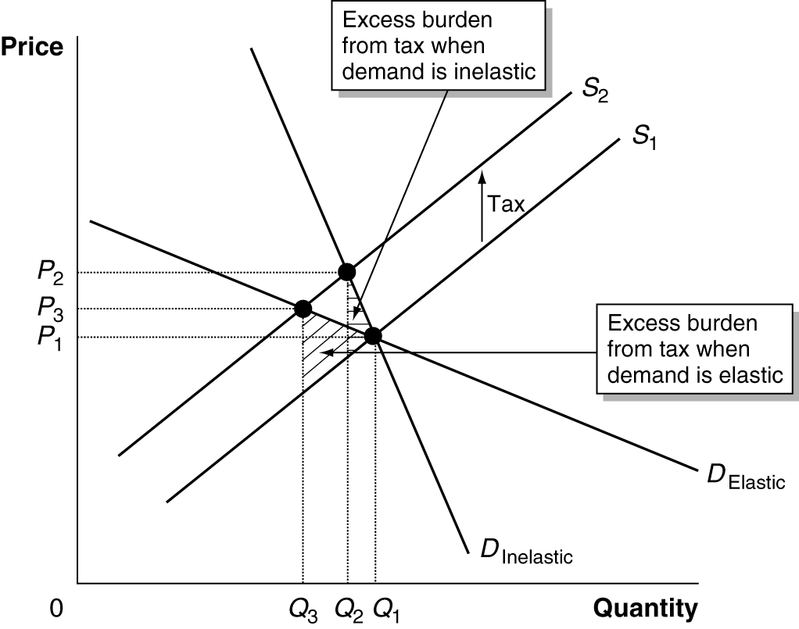

7a. The price consumers pay will rise more if the demand curve is less elastic, which would be demand curve D₂ in this case. In the figure below, the supply curve has shifted upward by 10 cents from S₁ to S₂. If the demand curve is D₁, then the price paid by consumers rises to $1.53. If the demand curve is D₂, then the price rises by more – to $1.57.

7b. The revenue to the government will be greater if the demand curve is D₂ because the quantity sold is greater for D₂ (Q₂) than for D₁ (Q₁).

7c. The excess burden will be greater if the demand curve is D₁ – which is more elastic. With demand curve D₁, the excess burden is the area = B + C. With demand curve D₂, the excess burden is the area = A + C.

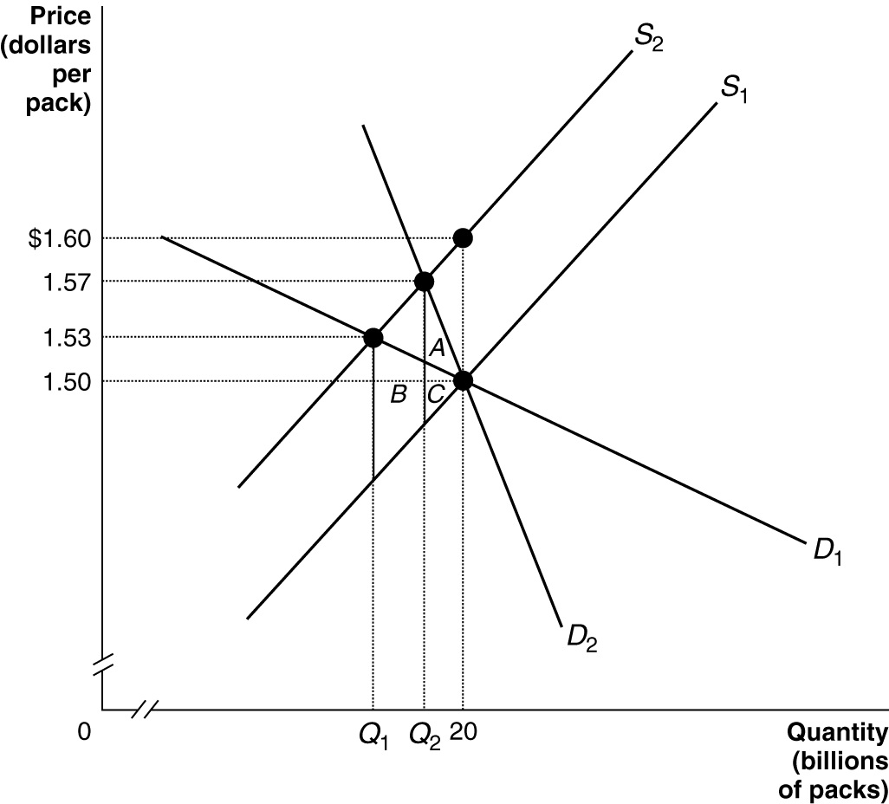

8a.

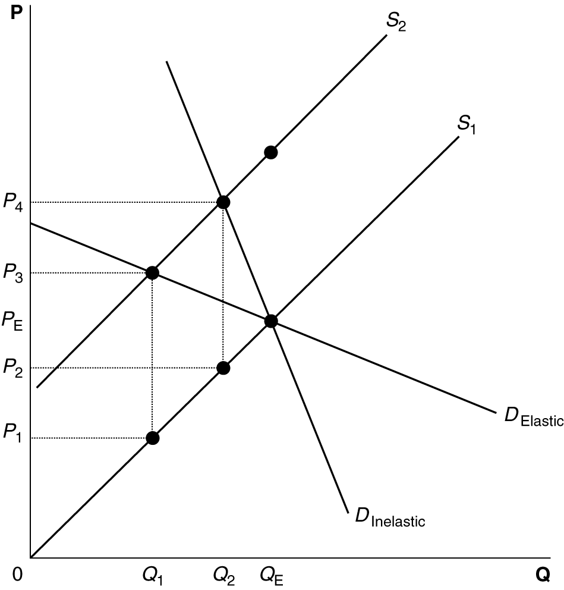

For a given supply curve, if the government wants to minimize the excess burden from excise taxes, the taxes should be imposed on goods that have price inelastic demand. See the figure from problem 7, which illustrates this point.

8b. For a given supply curve, if the government wishes to maximize revenue, it should impose excise taxes on goods that have price inelastic demand. As the figure below shows, with an elastic demand curve the quantity sold will fall from Q_{E} to Q₁, so revenue will be the area Q₁ x (P₃ – P₁), while the revenue will be Q₂ x (P₄ – P₂) when the demand curve is inelastic. Q₂ is much larger than Q₁, while (P₄ – P₂) = (P₃ – P₁) = the amount of the tax. Thus, the tax revenue is much larger when the demand curve is inelastic, because the quantity sold is larger.
8c. If the government wishes to discourage use of the product, the tax will be more effective in achieving the objective if the demand is price elastic. As shown in the figure, the quantity demanded will fall more when the demand curve is elastic.

9. The lottery “tax” is generally considered to be regressive because data show that poorer people spend a greater share of their incomes on lottery tickets than do people with higher incomes.

10. It is unlikely that this statement is true. The burden of a tax generally falls on both buyer and seller. If the tax didn’t exist, it is likely that the list price would have been more than $300. Only if the demand curve is vertical or the supply curve is horizontal, will buyers bear the entire burden of the tax.

11. For a given demand curve, when supply is less elastic (S₁), the excess burden of the tax is area A. When supply is more elastic (S₂), the excess burden of the tax is area B. Therefore, the excess burden of the tax is greater when supply is more elastic.

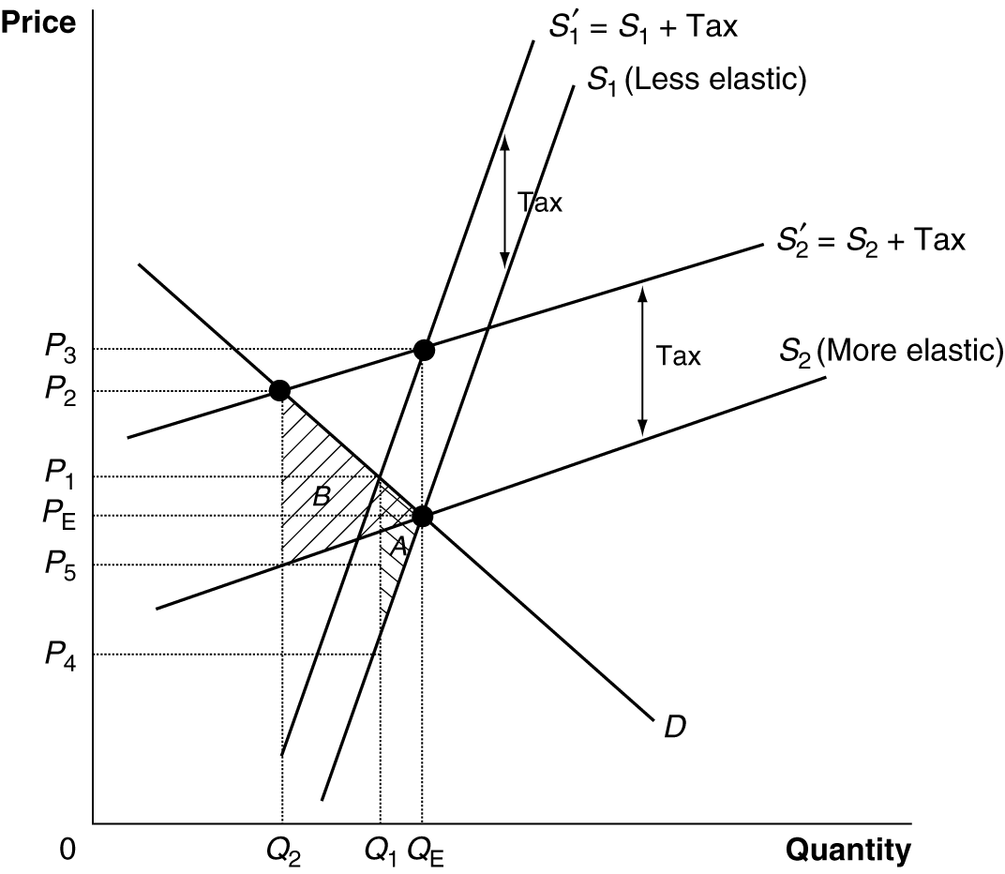

12. While policies to redistribute income may be desperately needed in the U.S., it doesn’t seem to be true that the 12 percent of the population that is currently poor has no hope of ever climbing above the poverty line. The chapter cites a study by the U.S. Census Bureau which found that only 50.5 percent of people who were in poverty in 1996 remained in poverty in 1999. Likewise, of the people who were in poverty at any time during 1996, 51.1 percent were in poverty for four months or less and only 20.4 percent were in poverty for more than one year.

13a. The distribution of income became less equal in 2007. The Lorenz Curve for 2007 is farther away from the diagonal line of equality than is the Lorenz Curve for 2006.

13b. The Gini Coefficient = (the area inside the Lorenz Curve)/(the area beneath the diagonal line of equality). Thus, for 2006, the Gini Coefficient = A/(A + B + C) = 0.43. For 2007, the Gini Coefficient = (A + B)/(A + B + C) = 0.48.

14.
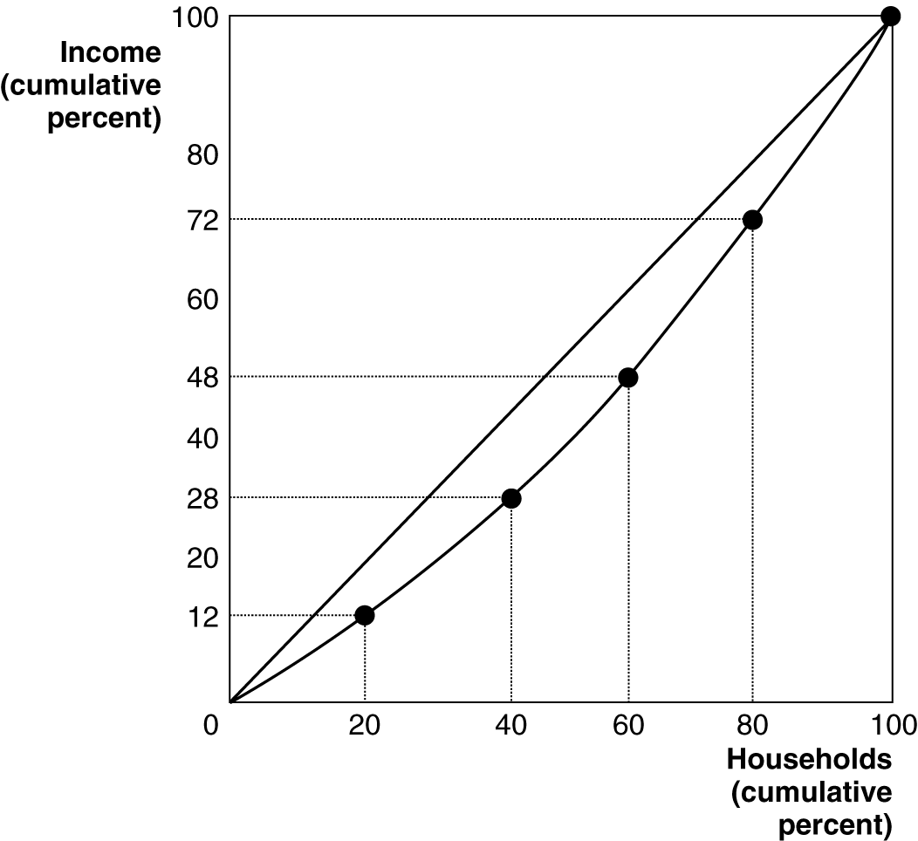

The total income of this group is $250,000.
Quintile Share of Income Cumulative Share of Income
Lowest 20% (Jeff) 12% 12%
Second lowest 20% (Robert) 16% 28%
Middle 20% (Sharon) 20% 48%
Second highest 20% (Lena) 24% 72%
Highest 20% (David) 28% 100%

15. Economists like to examine both absolute poverty – measured in dollars or the amount of goods and services that a household can buy in comparison to an objective measure of the amount needed to survive or live at a healthy standard – and relative poverty – measured in comparison to the overall average of a society. The $2 per day standard of living is a useful measure of absolute poverty, since it is very difficult for someone to survive at a healthy standard of living with an income below $2 per day (although some people do). If this standard of poverty were used for rich countries, like the U.S., virtually no one would be recorded as living in poverty. However, many people in the U.S. live at a standard that is considered pretty poor by the high standards of the country. To measure this kind of poverty, a higher standard is used, such as the $19,157 per year standard for a family of four. Such families do not live in the absolute poverty of people trying to get by on $2 per day, but they are considered relatively impoverished by people in their country. Likewise, the American poverty standard wouldn’t be very useful for people in sub-Saharan Africa. A family of four living on $19,157 per year in a country like Nigeria wouldn’t be considered impoverished by its fellow citizens.
16. According to the marginal productivity theory of income distribution, the distribution of income is based mainly on the marginal revenue product of the factors owned by households. To equalize the distribution of income would require ending the inequality of ownership of resources or ending the inequality of the payments to these resources (by, for example, making wage rates equal). This would require a massive government intervention into the economy, greater even than under the old communist governments of Russia and China, which never achieved complete income equality. Such a policy would not be very desirable because it would destroy the efficiency of the economy. There would be no incentives to work hard, save, become educated, take entrepreneurial risks, and so forth, if people knew that their income would be the same as everyone else’s whether or not they worked, saved, became educated or took risks.

17. It seems to be impossible to compare the well-being (or utility) of one person to another. Even if one could, it is probably that some people would be able to achieve more well-being than others from a certain level of income. For example, a person in good health would probably have a higher level of well-being than a person in poor health who had the same level of income.

18. Food is often exempt from taxation because of the ability-to-pay principle. Poorer households generally spend a much larger fraction of their incomes on food, which is a necessity. In satisfying these basic needs, they don’t have as great an ability to pay taxes as households with higher incomes. The exemption of services from sales taxes is much harder to understand using the principles of taxation. Taxing services at a lower rate than goods can undermine the goal of achieving economic efficiency. It may be that the exemption of services is an effort to attain other social objectives. It is much easier for tax collectors to keep an eye on the sales of goods, so the exemption of sales may be a bow to the likelihood of tax evasion if services were taxed.

19. It is extremely unlikely that the incomes of the poor would rise by $6000. Faced with the higher marginal tax rate, rich households are likely to work less, earn less and thus pay less than $6000 each in taxes. Likewise, many poorer households will respond to the transfer by working less, so their pre-transfer labor market earnings will fall below $20,000.

20. The poverty line is defined as an annual income equal to three times the amount necessary to purchase the minimal quantity of food require for adequate nutrition – and it is calculated before taxes and transfers. There are many reasons why consumption and ownership of these goods could rise while poverty rates stay the same. Most importantly, the poverty rate is based on income and consumption can differ from income, due to transfers, for example. Another reason is that the definition of “adequate” nutrition seems to have risen over time, increasing the purchasing power of those at the poverty line.

